Name : Abdul Rehman Section :B

Course : CCN Roll No : CT-22052

---------------------------------------------------------------------------------------------------------------------  
  
**Lab # 4:**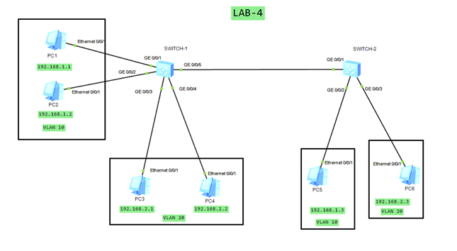

**SWITCH -1 CONFIGURATION:**

#

vlan batch 10 20

#

interface GigabitEthernet0/0/1

port link-type access

port default vlan 10

#

interface GigabitEthernet0/0/2

port link-type access

port default vlan 10

#

interface GigabitEthernet0/0/3

port link-type access

port default vlan 20

#

interface GigabitEthernet0/0/4

port link-type access

port default vlan 20

#

interface GigabitEthernet0/0/5

port link-type trunk

port trunk allow-pass vlan 10 20

#

**SWITCH -2 CONFIGURATION:**

#

vlan batch 10 20

#

interface GigabitEthernet0/0/1

port link-type trunk

port trunk allow-pass vlan 10 20

#

interface GigabitEthernet0/0/2

port link-type access

port default vlan 10

#

interface GigabitEthernet0/0/3

port link-type access

port default vlan 20

#